Tupperware
Graphics Format
Definition
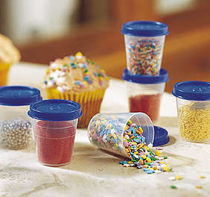

Revision 0.7e
3/19/2002

Copyright 2001-2002 Avalanche Software
Proprietary and Confidential Information
TABLE OF CONTENTS
Introduction 3
What is Tupperware? 3
Focus of the Graphics Definition 3
Filter Chain 3
Issues with 3DStudio Max 4
Tupperware Information 7
Symbols for Tupperware Atom Types 7
Scene 8
Nodes 9
Objects 11
TriMesh Object 11
Derived Object 14
XRef Object 15
Light Object 15
Camera Object 18
Path Object 20
Modifiers 21
FaceAttribute Modifier 21
ApplyVC Modifier 22
VertexPaint Modifier 22
HoldVC Modifier 25
Unknown Modifier 25
Transform 27
Transform StaticMatrix 27
Materials 28
Standard Material 28
MultiSubObject Material 33
Blend Material 34
Composite Material 35
DoubleSided Material 36
Maps 37
Bitmap Map 37
Composite Map 41
Images 42
Image Data 43

Introduction
This document holds the current definition of the graphics format used in the new pipeline. This format relies on the Tupperware library to store its data.

What is Tupperware?
Tupperware uses basic building blocks (Atoms); aggregates, scalars, and lists to store its data. This data is arranged in a hierarchy to make it easier to access. Each building atom has a key and a name. The key is a string used for finding and is not optional. The name is optional and is used to distinguish between atoms that have the same key or to hold additional information.
An aggregate atom holds no data but has child atoms. A scalar holds a single piece of data; integer, float, string, or binary. A list holds an array of data; integers, floats, or strings.
The Tupperware library allows for interacting with the atoms as well as supporting an ASCII as well as a binary file format.
Using Tupperware allows for representing the graphic data in a general way that allows for expandability as well as for data outside of this definition to be stored in a transparent way.

Focus of the Graphics Definition
The new artwork pipeline relies on the use of 3DStudio Max as its core artwork program. This graphics definition is based on the internal structure of Max. This allows for future data to be added without starting over. Any differences between the game engine data and this definition will be handled through the use of the filter chain.

Filter Chain
In the process of converting the data from this format to the game data the Tupperware tree goes through a set of filters called the filter chain. Each filter has access to the Tupperware tree and can manipulate any part of it as well as add additional data not part of this definition. The Tupperware tree is then passed to the next filter. The last filter in the chain could then save out the game specific file.

Issues with 3DStudio Max
Issues that may impact those who are writing filters are as follows:

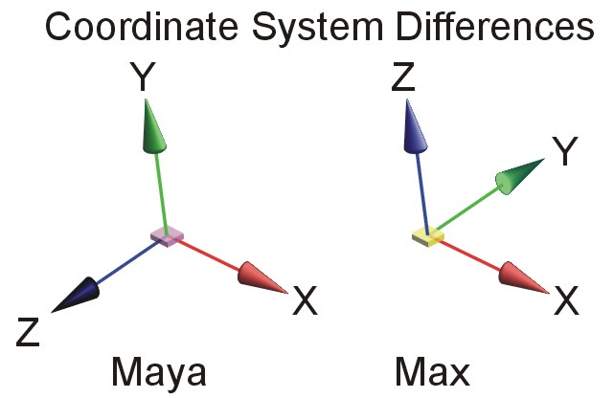
Coordinate System
The coordinate system within max is z-up (right-handed). Many other programs need a y-up (right-handed) coordinate system.

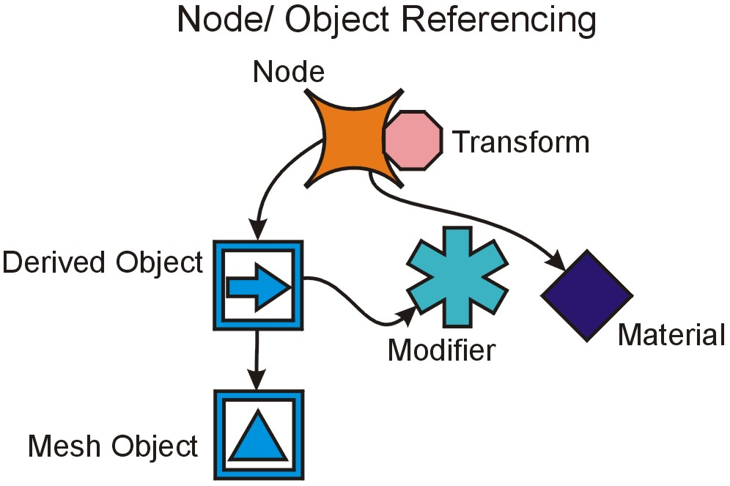
Object Referencing and Modifiers
The method max uses for referencing objects can be complex. Each node in the scene points to an object. A chain of derived objects may be created with modifiers attached to each. All objects, modifiers, and materials may be shared between the nodes.
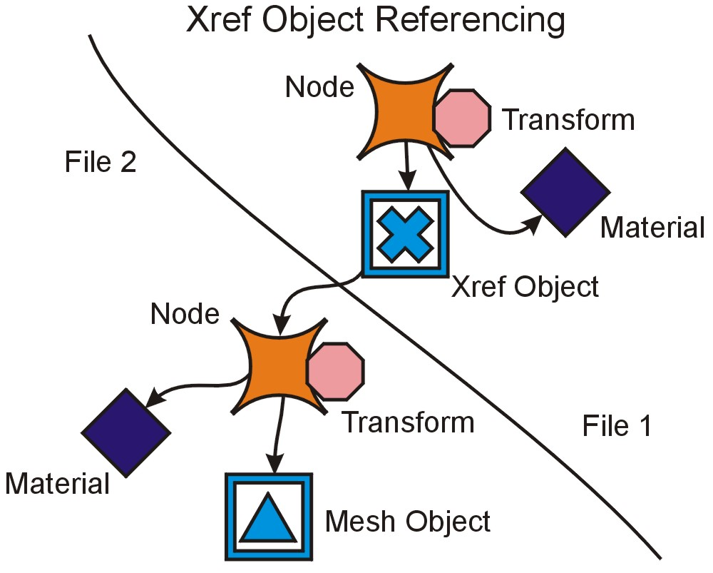

XRef Objects
An xref objects points to another node in another file. This allows for a world file to reference the meshes externally. When processing the artwork, the ideal situation would be to handle the world file separately from the referenced objects.

Multi – Sub Object Materials
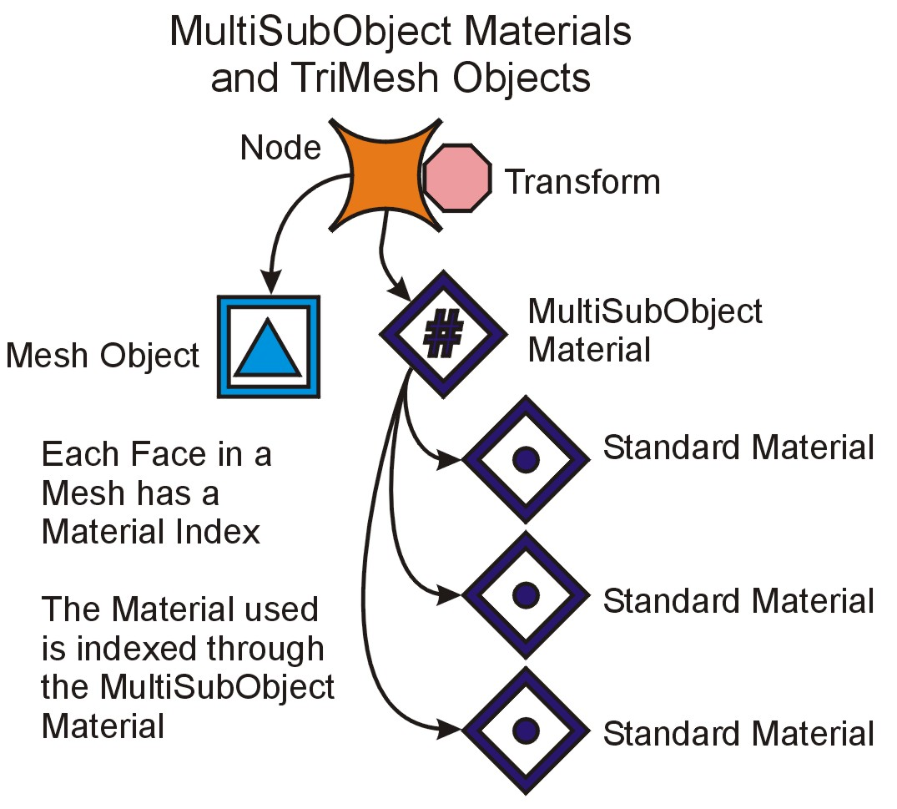
To handle a triangle mesh with access to more than one material, a MultiSubObject Material is used. Each face within the mesh has a material index which is used as an index within the multi sub object material referenced by the node.
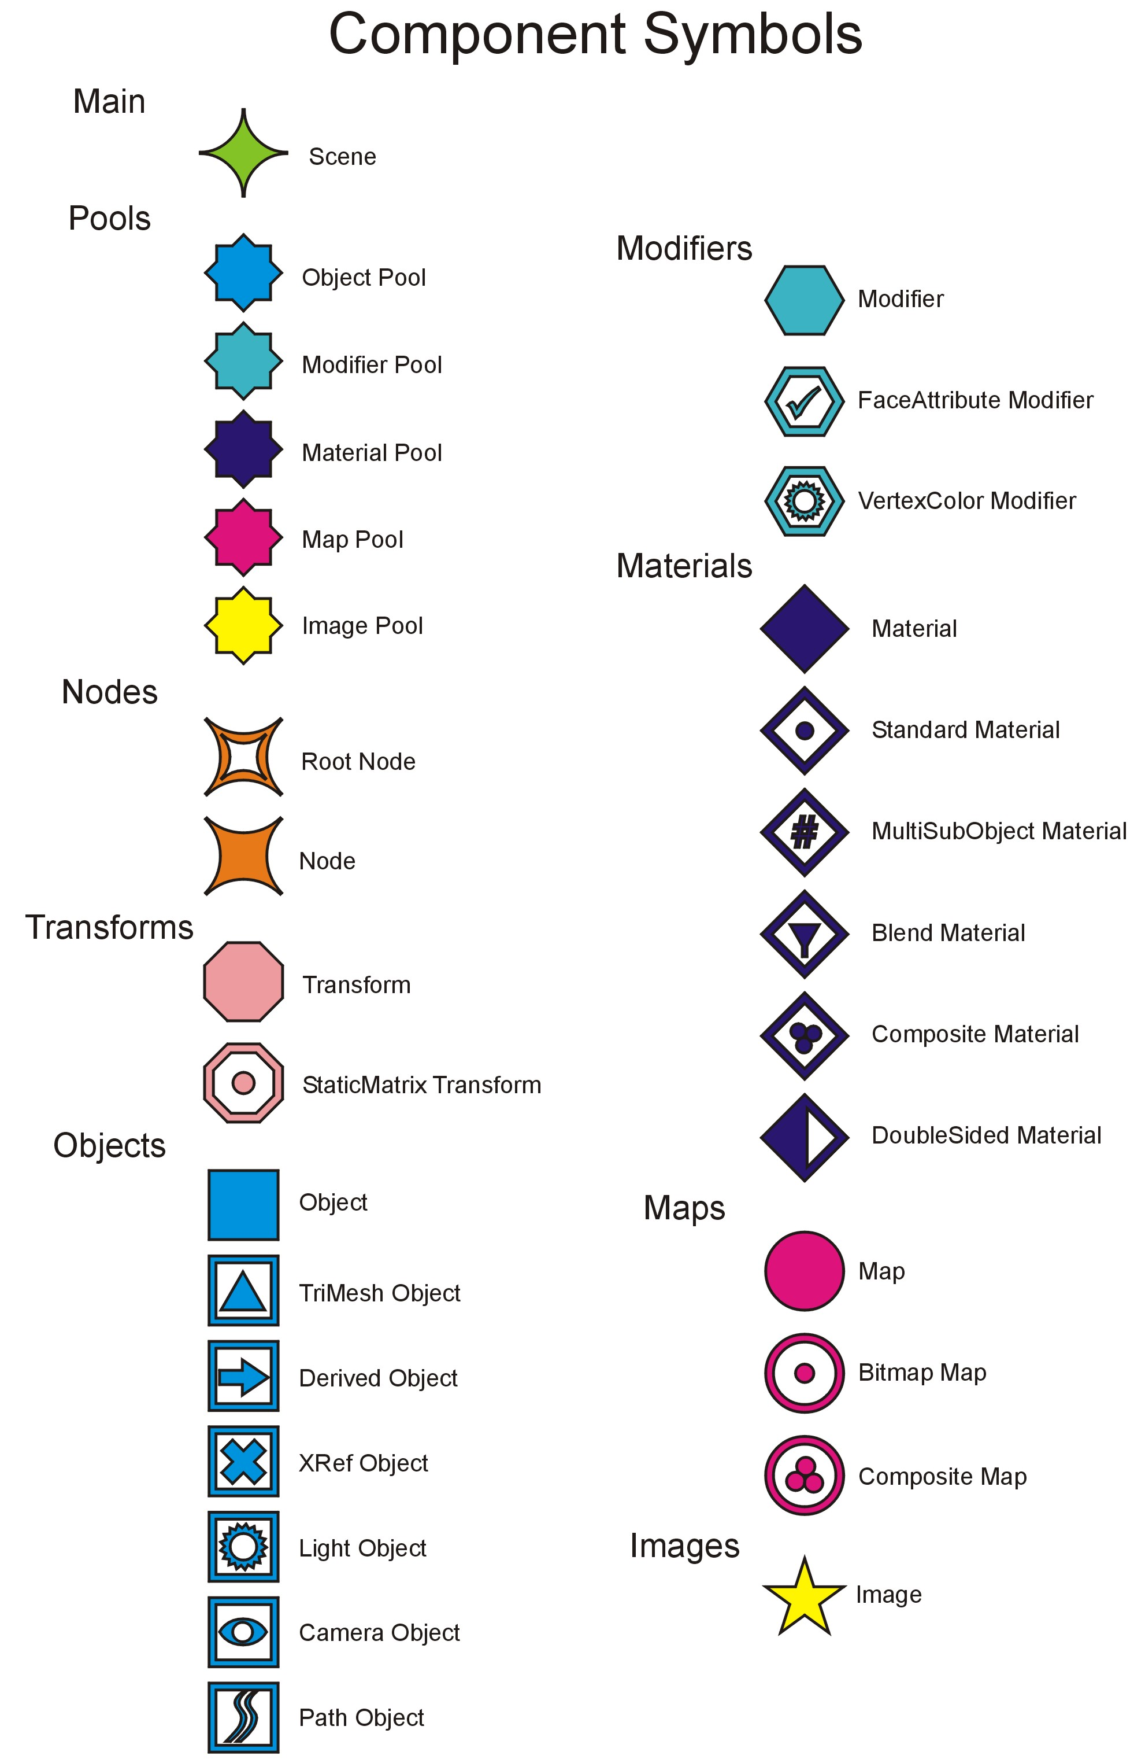

Tupperware Information

Symbols for Tupperware Atom Types

A – Aggregate
This atom is the only atom type that can have children. It cannot hold any data other than other atoms.

FS – Floating Point Scalar
This atom holds a single 32 bit floating point number.

IS – Integer Scalar
This atom holds a single 32 bit integer number.

SS – String Scalar
This atom holds an array of characters. The last character is a NULL character ‘\0’.

BS – Binary Scalar
This atom holds a block of binary data. It may also contain a filename in which the data may be obtained or written to disk and flushed from memory.

FL – Floating Point List
This atom holds an array of 32 but floating point numbers.

IL – Integer List
This atom holds an array of 32 bit integer numbers.

SL – String List
This atom holds an array of strings. Each entry points to an array of characters.

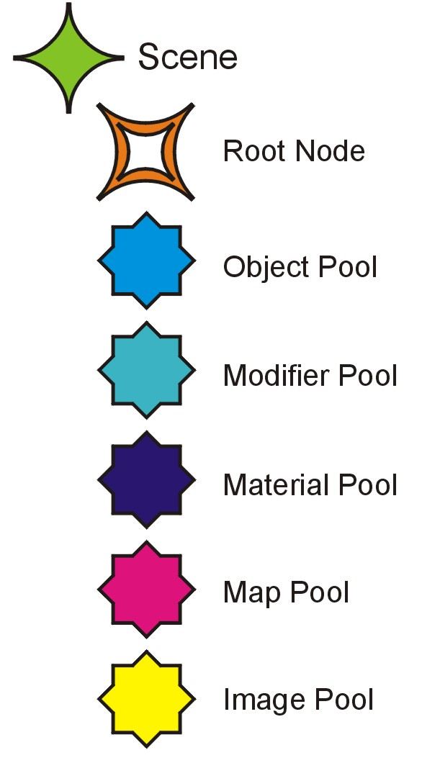
Scene

A Scene
This is the parent atom for the entire scene.

A NodePool
This atom holds all the nodes used in the scene. Each child of this aggregate uses its name as a unique number string to allow it to be referenced.

IS RootNodeReference
This atom holds the index to the Root node for the scene. This holds a value that is used to lookup within the NodePool.

A ObjectPool
This atom holds all the objects used in the scene. Each child of this aggregate uses its name as a unique number string to allow it to be referenced.

A ModifierPool
This atom holds all the modifiers used in the scene. Each child of this aggregate uses its name as a unique number string to allow it to be referenced.

A MaterialPool
This atom holds all the materials used in the scene. Each child of this aggregate uses its name as a unique number string to allow it to be referenced.

A MapPool
This atom holds all the maps used in the scene. Each child of this aggregate uses its name as a unique number string to allow it to be referenced.

A ImagePool
This atom holds all the images used in the scene. Each child of this aggregate uses its name as a unique number string to allow it to be referenced.

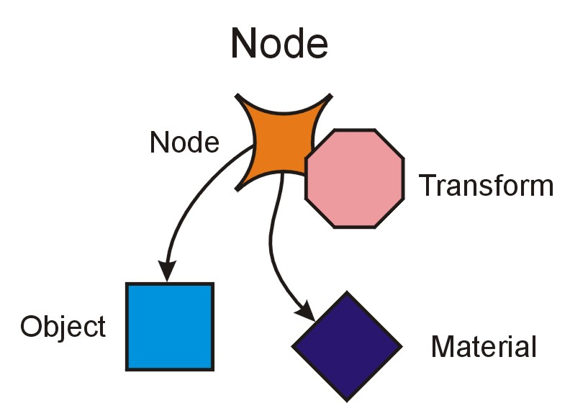
Nodes

A Node
This aggregate holds all the data needed for a node in the scene. Its name is a unique identifier within the NodePool.

SS Name
This is the name of the node

IS ObjectReference
This holds a 32 bit number used for accessing the correct object within the object pool. If there is no object this value will be -1.

IS MaterialReference
This holds a 32 bit number used for accessing correct material within the material pool. If this value is -1 the node does not use a material.

FL WireframeColor
This holds 3 floating point values representing the wireframe color used in Max.

Transform
This aggregate holds the current transform of the node.

IS ParentNodeReference
This integer scalar holds the parent node reference within the node pool. If the node is the root node this value is -1.

A Children
This aggregate holds the node references to the children of this node.

IS ChildNodeReference
This integer scalar holds a node reference to a child of the parent node. This is an index into the node pool.

IS Flags
The flags for the node. The following are the valid flags:

Bit 0 – Hidden
Bit 1 – Frozen
Bit 2 – Frozen with Material
Bit 3 – Box Display
Bit 4 – Vertical Ticks Display
Bit 5 – Edge Display
Bit 6 – Back Culling Display
Bit 7 – Trajectory Display
Bit 8 – Xray Material Display

SS UserProperties
This is a string buffer used to hold the user property data. This works like a text file for the node that can be any length.

Objects

A Object
This aggregate belongs as a child of the ObjectPool aggregate. Its name is a unique identifier within the ObjectPool.

SS ObjectType
This string indicates what type of object it is.

TriMesh Object
A trimesh object holds a pool of triangles. It contains the position, normal, and other mapping channels as well as face information.

FL PositionVerts
3 floats per position, size of list is number of positions*3

IL PositionIndices
3 ints per face, size of list is number of faces*3

FL NormalVerts
3 floats per normal, size of list is number of normals*3

IL NormalIndices
3 ints per face, size of list is number of faces*3

IL FaceFlags
1 int per face, size of list is number of faces
bits 0-2 are edge visibility flags
bit 3 indicates if face is hidden

IL FaceMaterialIndices
1 int per face, size of list is number of faces
This is an index into the list of materials (in a multi-sub object material). This allows for multiple materials per mesh.

IL FaceShadingGroups
1 int per face, size of list is number of faces
32 shading groups 1 bit per shading group
bit 0 is shading group 1
bit 31 is shading group 32

FL FaceNormalVerts
3 floats per normal, size of list is number of normals*3

IL FaceNormalIndices
1 int per face, size of list is number of faces

A MeshMaps
This aggregate holds all the different maps used in the mesh. Each map holds 3 floating point values per point per face.

A MeshMap “Channel”
This Aggregate holds one meshmap. The name of this aggregate is the channel number of the meshmap.

IS MapFlags
The flags hold information about what type of map this is.

FL MapVerts
3 floats per map vertex, size of list is number of map verts*3

IL MapIndices
3 ints per face, size of list is number of faces*3

A TriangleStrips
This aggregate holds the triangle strip information built by the TriStrip filter plugin.

A TriangleStrip “Index”
This aggregate holds a single triangle strip. The name is the index within the parent aggregate.

IL FaceIndices
This integer list holds the face indices for the triangle strip. The length of this list is the number of points. Each entry is used to access the other triangle data within the mesh and is the face index to use.

IL FacePointIndices
This integer list holds the face point indices for the triangle strip. The length of this list is the number of points. Each entry is used to access the other triangle data within the mesh and is the point of the face to use (0-2).

Derived Object
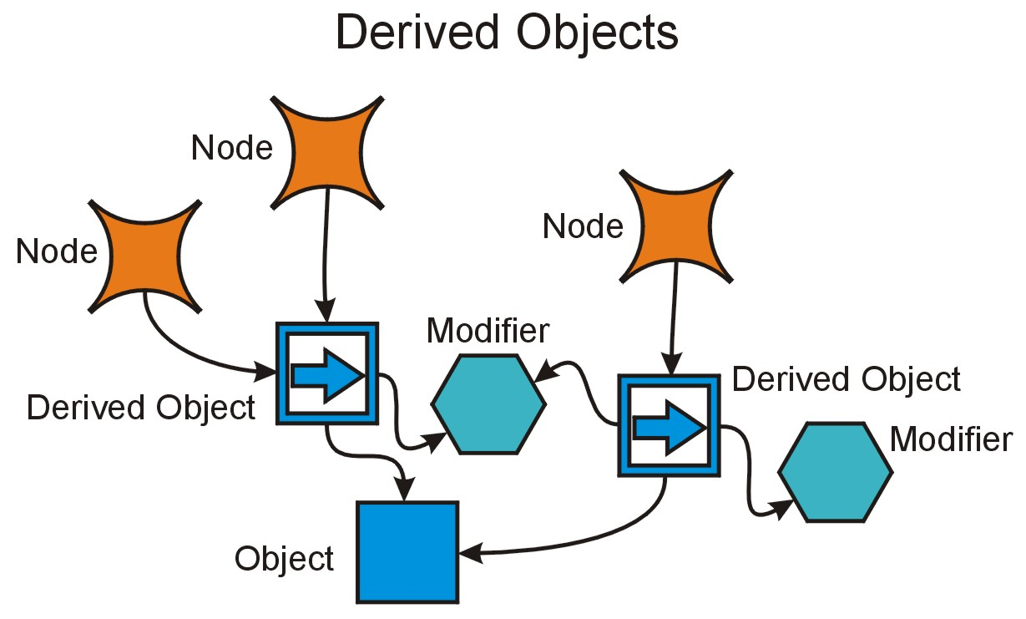
A derived object is an object that can hold modifiers. A modifier can manipulate the pipeline as well as add additional data to it.

A Modifiers
This aggregate holds all the modifiers that are accessed within the derived object.

A Modifier “Index”
This aggregate holds a single modifier. The name of this aggregate holds the index value with the modifiers. The index value is the order of the modifier within the list.

IS ModifierReference
This holds a 32 bit number used for accessing the modifier within the modifier pool.

A ModifierContext
This aggregate holds the local data for the modifier for the derived object.

IS ObjectReference
This holds a 32 bit number used for accessing the next object within the pipeline. This index is used within the ObjectPool.

XRef Object
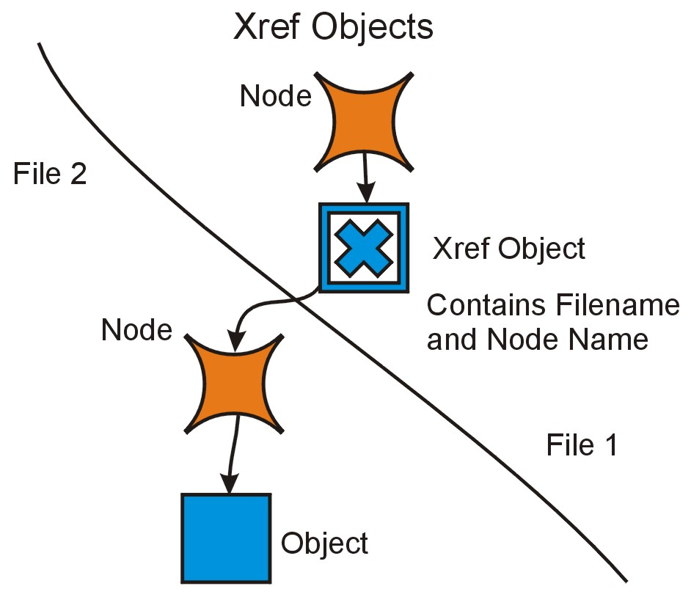
An xref object directs points to another node within another file.

SS Filename
This string contains the filename and path for the xref file.

SS NodeName
This string contains the name of the node within the xref file.

Light Object
A light object holds the properties of the light.

IS LightType
This holds the type of the light. The valid values are as follows:

0 – Omni
1 – Target Spot
2 – Free Spot
3 – Target Direct
4 – Free Direct

FL LightColor
This holds a floating point list of the light color.

FS Multiplier
This holds the light multiplier value.

FS AffectSurfacesContrast
This holds the Affect Surfaces Contrast value. This value ranges from 0-100.

FS AffectSurfacesSoftenDiffEdge
This holds the Affect Surfaces Soften Diff Edge value.

IS ProjectorMapReference
This holds a reference to the map pool for the projector map. If there is no map this value is -1.

FS LightConeHotspot
This holds the light cone hotspot value.

FS LightConeFalloff
This holds the light cone falloff value.

FS LightConeRectangleAspectRatio
This holds the aspect ratio for the rectangle light cone.

FS TargetDistance
This holds the target distance value.

FS NearAttenuationStart
This holds the near attenuation start value.

FS NearAttenuationEnd
This holds the near attenuation end value.

FS FarAttenuationStart
This holds the far attenuation start value.

FS FarAttenuationEnd
This holds the far attenuation end value.

IS AttenuationDecayType
This holds the attenuation decay type. The valid values are:

0 – None
1 – Inverse
2 – Inverse Square

FS AttenuationDecayStart
This holds the attenuation decay start value.

IS ShadowType
This holds the shadow type. The valid values are a follows:

0 – Shadow Map
1 – Ray Traced Shadows

FL ShadowColor
This holds the shadow color.

FS ShadowDensity
This holds the shadow density.

IS ShadowMapReference
This holds the reference to the map pool for the shadow map. If this value is -1 there is no map.

FS AtmosphereShadowsOpacity
This holds the opacity value for atmosphere shadows.

FS AtmosphereShadowsColorAmount
This holds the color amount for atmosphere shadows.

FS ShadowMapBias
This holds the shadow map bias value.

IS ShadowMapSize
This holds the size of the shadow map.

FS ShadowMapSampleRange
This holds the sample range for the shadow map.

FS RayTraceBias
This holds the ray trace bias value.

IS RayTraceMaxDepth
This holds the ray trace max depth value.

IS Flags
This holds the flags for the light. Following are the valid flags:

Bit 0 – Enable
Bit 1 – Cast Shadows
Bit 2 – Affect Surfaces Diffuse
Bit 3 – Affect Surfaces Specular
Bit 4 – Affect Surfaces Ambient Only
Bit 5 – Show Light Cone
Bit 6 – Light Cone Overshoot
Bit 7 – Light Cone Circle
Bit 8 – Projector Map Enable
Bit 9 – Near Attenuation Use
Bit 10 – Near Attenuation Show
Bit 11 – Far Attenuation Use
Bit 12 – Far Attenuation Show
Bit 13 – Attenuation Decay Show
Bit 14 – Object Shadows Use Global Settings
Bit 15 – Object Shadows Map Enable
Bit 16 – Object Shadows Light Affects Shadow Color
Bit 17 – Atmosphere Shadows On
Bit 18 – Shadow Map Absolute Map Bias

Camera Object
A camera object holds the properties of the camera.

FS CameraLens
This holds the lens setting from 9.857 and up. This is the lens size in millimeters.

FS FieldOfViewHorizontal
This floating point scalar holds the field of view in radians based on the horizontal ratio.

FS FieldOfViewVertical
This floating point scalar holds the field of view in radians based on the vertical ratio.

FS FieldOfViewDiagonal
This floating point scalar holds the field of view in radians based on the diagonal ratio.

IS CameraType
This is the type of camera it is. Following are the valid types:
0 – Free Camera
1 – Target Camera

FS EnvironmentNearRange
This holds a floating point value which is the environment near range. This value is >=0 and <= the environment far range.

FS EnvironmentFarRange
This holds a floating point value which is the environment far range. This value is >= the environment near range.

FS NearClip
This holds a floating point value which is the clipping planes near clip value. This value is >=0 and <= the far clip value.

FS FarClip
This holds a floating point value which is the clipping planes far clip value. This value is >= the near clip value.

FS TargetDistance
This holds a floating point value which is the target distance for the target camera. This value is >=1.

IS Flags
This holds the flags for the camera. Following are the flag bits:

Bit 0 – Orthographic Projection
Bit 1 – Show Cone
Bit 2 – Show Horizon
Bit 3 – Show Environment Ranges
Bit 4 – Clip Manually

Path Object
A path object holds curve for the path.

Modifiers

A Modifier
This aggregate belongs as a child of the ModifierPool aggregate. Its name is a unique identifier within the ModifierPool.

SS ModifierType
This scalar holds a string indicating the type of modifier it is.

FaceAttribute Modifier
This modifier is used to store face attribute data for a mesh.

Modifier Data
This is the data attached to the modifier. This data is shared between instances of the modifier.

SS Name
This holds the name of the modifier.

IS Flags
This holds the flags for the modifier. Following are the flag values:

Bit 0 – Enabled

ModifierContext Local Data
This is the local data unique to this modifier that is stored within the derived object.

SL FaceAttributeVerts
1 string entry (each string holds ASCII data for a set of user face data and can be multiple lines)

IL FaceAttributeIndices
1 int per face, size of list is number of faces

ApplyVC Modifier
This modifier is used by the assign vertex colors utility in Max. Lights from the scene are computed and placed in a modifier for each object.

Modifier Data
This is the data attached to the modifier. This data is shared between instances of the modifier.

SS Name
This holds the name of the modifier.

FL ColorVerts
3 floats per color vertex, size of list is number of map verts*3

IL ColorIndices
3 ints per face, size of list is number of faces*3

IS Flags
This holds the flags for the modifier. Following are the flag values:

Bit 0 – Enabled
Bit 1 – Mixed Colors

Notes:
There are two ways that the ColorIndices list is stored. If the Mixed Colors Flag is set these indices are in sync with the vertex positions within the mesh. If the Mixed Colors Flag is not set the indices are 3 indices per face in the mesh.

VertexPaint Modifier
This modifier is used to for painting colors on a mesh.

Modifier Data
This is the data attached to the modifier. This data is shared between instances of the modifier.

SS Name
This holds the name of the modifier.

IS Flags
This holds the flags for the modifier. Following are the flag values:

Bit 0 – Enabled

ModifierContext Local Data
This is the local data unique to this modifier that is stored within the derived object.

FL VertexColorChannelColors
This holds a list of colors for the Vertex Color Channel. The size of the list is the number of colors *3.

FL VertexColorChannelMixFactors
This holds a list of mix colors for the Vertex Color Channel. The size of the list is the number of colors.

IL VertexColorChannelFaceIndices
This holds a list of face indices for the Vertex Color Channel. The size of the list is the number of colors.

IL VertexColorChannelPointIndices
This holds a list of point indices for the Vertex Color Channel. The size of the list is the number of colors.

FL IlluminationChannelColors
This holds a list of colors for the Illumination Color Channel. The size of the list is the number of colors *3.

FL IlluminationChannelMixFactors
This holds a list of mix colors for the Illumination Channel. The size of the list is the number of colors.

IL IlluminationChannelFaceIndices
This holds a list of face indices for the Illumination Channel. The size of the list is the number of colors.

IL IlluminationChannelPointIndices
This holds a list of point indices for the Illumination Channel. The size of the list is the number of colors.

FL AlphaChannelColors
This holds a list of alpha values for the Alpha Color Channel. The size of the list is the number of colors.

FL AlphaChannelMixFactors
This holds a list of mix colors for the Alpha Channel. The size of the list is the number of colors.

IL AlphaChannelFaceIndices
This holds a list of face indices for the Alpha Channel. The size of the list is the number of colors.

IL AlphaChannelPointIndices
This holds a list of point indices for the Alpha Channel. The size of the list is the number of colors.

Notes:
Each channel is composed of four items; the colors, mix factors, face indices, and point indices.

If a channel is not active then these items will not be written to the file.

Each entry in each of these lists corresponds to a specific face and point on that face. The result color is determined by mixing a source color in the mesh with the color given in the color list. The source color is found by using the face index and the point index in the current mesh. The formula for mixing is as follows:

Result color = (source color *(1-mix factor))+(color*(mix factor))

The result color is then applied to the current face point as well as to all other face points that share the same position within the vertex position list as the current face point.

HoldVC Modifier
This modifier is used by the hold vertex colors utility in Max.

Modifier Data
This is the data attached to the modifier. This data is shared between instances of the modifier.

SS Name
This holds the name of the modifier.

FL ColorVerts
3 floats per color vertex, size of list is number of map verts*3

IL ColorIndices
3 ints per face, size of list is number of faces*3

IS Flags
This holds the flags for the modifier. Following are the flag values:

Bit 0 – Enabled

Unknown Modifier
This modifier is used for to for painting colors on a mesh.

Modifier Data
This is the data attached to the modifier. This data is shared between instances of the modifier.

SS Name
This holds the name of the modifier.

IS Flags
This holds the flags for the modifier. Following are the flag values:

Bit 0 – Enabled

ModifierContext Local Data
This is the local data unique to this modifier that is stored within the derived object.

Transform

Transform
The transformation information exists within a node in the scene. At this current time the only type of transformation that is supported is a static matrix.

A Transform
This aggregate holds the current transform of the node.

SS TransformType
This string holds the type of transform. At this time the string should be “StaticMatrix”.

Transform StaticMatrix
The staticmatrix transform holds a single 4x4 matrix.

FL Matrix4x4
This floating point list contains 16 floats. The matrix data is in the following format:

R00,R01,R02,U0
R10,R11,R12,U1
R20,R21,R22,U2
Tx,Ty,Tz,w

Materials

A Material
This aggregate belongs as a child of the MaterialPool aggregate. Its name is a unique identifier within the MaterialPool.

SS MaterialType
This string indicates what type of material it is.

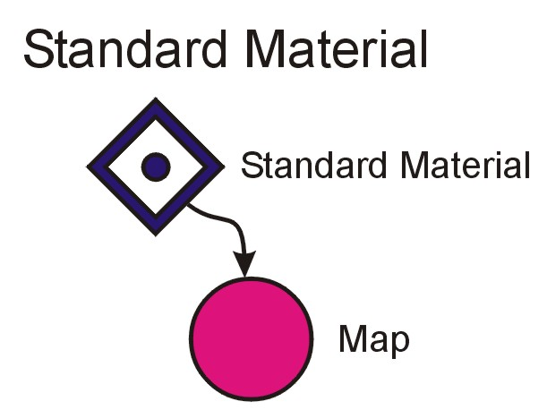
Standard Material
This material does not have any sub materials. It handles the basic parameters for a material as well as pointing to maps.

SS Name
This string holds the name of the material.

FL AmbientColor
This float list holds 3 floating point values for the Ambient Color. Each value is in the range of 0-1.

FL DiffuseColor
This float list holds 3 floating point values for the Diffuse Color. Each value is in the range of 0-1.

FL SpecularColor
This float list holds 3 floating point values for the Specular Color. Each value is in the range of 0-1.

FL FilterColor
This float list holds 3 floating point values for the Transparency Filter Color. Each value is in the range of 0-1.

FS Glossiness
This float scalar holds the specular highlight glossiness value. This value is from 0-1.

FS SpecularLevel
This float scalar holds the specular highlight specular level value. This value is from 0-9.99.

FS SpecularSoftnen
This float scalar holds the specular hightlight soften value. This value is from 0-1.

FS Transparency
This float scalar holds the transparency value.

FS WireSize
This float scalar holds the wire size.

FS IndexOfRefraction
This float scalar holds the index of refraction value.

FS ReflectionDimIntensity
This float scalar holds the reflection dim level value.

FS ReflectionDimMultiplier
This float scalar holds the reflection dim multiplier value.

FS SoftnessLevel
This float scalar holds the softness level value.

FS Opacity
This float scalar holds the opacity value.

FS OpacityFalloff
This float scalar holds the opacity falloff value.

IS TransparencyType
This integer scalar holds the type of transparency. The possible values are as follows:

0 – Subtractive
1 – Additive
2 – Filter

SS ShadingTypeName
This string scalar holds the name of the shading done with this material. Some of the valid values are: The possible values are: Anisotropic, Blinn, Metal, Multi-Layer, Oren-Nayar-Blinn, Phong, & Strauss.

FS SelfIllumination
This float scalar holds the self illumination value.

IS Flags
This integer scalar holds a series of flags. The flags are as follows:

Bit 0 – Soften
Bit 1 – Face Mapping
Bit 2 – Two Sided
Bit 3 – Wire
Bit 4 – Wire Units
Bit 5 – Falloff Out
Bit 6 – Ambient Diffuse Map Lock
Bit 7 – Ambient Diffuse Color Lock
Bit 8 – Diffuse Specular Color Lock
Bit 9 – Self Illumination Color
Bit 10 – Reflection Dimming Apply

A Maps
This aggregate holds all the map information as well as references to the map pool.

A Map “Channel Number”
This aggregate holds a map to be applied to the material. The name of this map is the channel number within the material.

IS Flags
This holds the flags for the sub material. The definition is as follows:

Bit 0 - Enabled

FS Amount
This holds a floating point value indicating the opacity of this map map. This is a value from 0-1.

IS MapReference
This holds a 32 bit number used for accessing the correct map within the map pool.

SS MapName
This holds a string which indicates the name of the map. The current map names based on the shading type name are as follows:

Anisotropic: Ambient Color, Diffuse Color, Specular Color, Diffuse Level, Specular Level, Glossiness, Anisotropy, Self-Illumination, Opacity, Filter Color, Bump, Reflection, Refraction, and Displacement.

Blinn: Ambient Color, Diffuse Color, Specular Color, Specular Level, Glossiness, Self-Illumination, Opacity, Filter Color, Bump, Reflection, Refraction, and Displacement.

Metal: Ambient Color, Diffuse Color, Specular Level, Glossiness, Self-Illumination, Opacity, Filter Color, Bump, Reflection, Refraction, and Displacement.

Multi-Layer: Ambient Color, Diffuse Color, Diffuse Level, Diff. Roughness, Specular Color 1, Specular Level 1, Glossiness 1, Anisotropy 1, Orientation 1, Specular Color 2, Specular Level 2, Glossiness 2, Anisotropy 2, Orientation 2, Self-Illumination, Opacity, Filter Color, Bump, Reflection, Refraction, and Displacement.

Oren-Nayar-Blinn: Ambient Color, Diffuse Color, Specular Color, Glossiness, Specular Level, Self-Illumination, Opacity, Filter Color, Diffuse Level, Diff. Roughness, Bump, Reflection, Refraction, and Displacement.

Phong: Ambient Color, Diffuse Color, Specular Color, Specular Level, Glossiness, Self-Illumination, Opacity, Filter Color, Bump, Reflection, Refraction, and Displacement.

Strauss: Color, Glossiness, Metalness, Opacity, Refr. Filter, Bump, Reflection, Refraction, and Displacement.

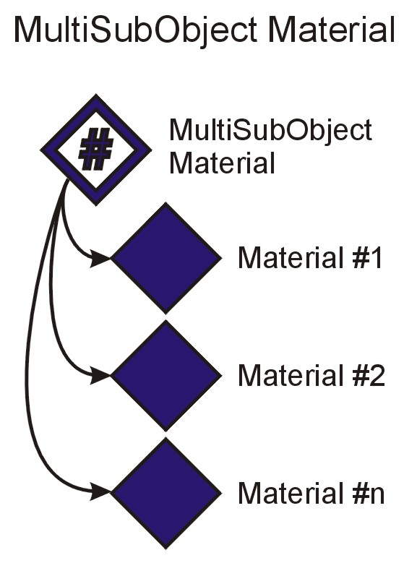
MultiSubObject Material
This material refers to other materials. This material is used on meshes that need to use more than one material.

SS Name
This string holds the name of the material.

A SubMaterials
This aggregate holds all the sub materials used by the material.

A SubMaterial “ID”
This aggregate holds information for a submaterial. The name of this aggregate is the id used by the meshes when referring to this material.

SS SlotName
This holds a string which is the name used within the multi material for the sub material.

IS Flags
This holds the flags for the sub material. The definition is as follows:

Bit 0 - Enabled

IS MaterialReference
This holds a 32 bit number used for accessing the correct material within the material pool.

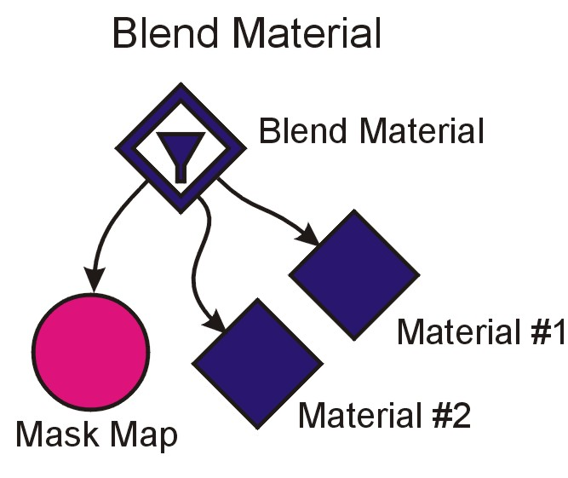
Blend Material
This material references two other materials as well as a mask map. The result of this material is a blend between the two.

SS Name
This string holds the name of the material.

IS Material1Reference
This holds a 32 bit number used for accessing the first material within the material pool. If there is no material this value is -1.

IS Material2Reference
This holds a 32 bit number used for accessing the second material within the material pool. If there is no material this value is -1.

IS MaskReference
This holds a 32 bit number used for accessing the mask map within the map pool. If there is no map this value is -1.

IS Flags
This holds the flags for the material. The definition is as follows:

Bit 0 – Material 1 Enabled
Bit 1 – Material 2 Enabled
Bit 2 – Mask Enabled
Bit 3 – Use Curve

FS MixAmount
This floating point scalar holds the mixing amount.

FS UpperTransitionZone
This floating point scalar holds the upper transition zone value.

FS LowerTransitionZone
This floating point scalar holds the lower transition zone value.

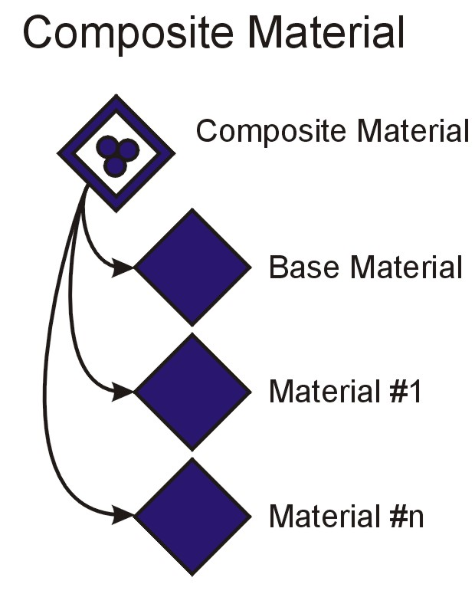
Composite Material
This material references up to 10 other materials and allows them to be composed together.

SS Name
This string holds the name of the material.

IS BaseMaterialReference
This holds a 32 bit number used for accessing the base material within the material pool. If there is no material this value is -1.

A SubMaterials
This aggregate holds all the sub materials used by the material.

A SubMaterial “Index”
This aggregate holds information for a submaterial. The name of this aggregate is the index of the material.

IS Flags
This holds the flags for the sub material. The definition is as follows:

Bit 0 – Enabled
Bits 1-2 Mixing Mode 0 – Additive 1 – Subtractive 2 – Mixed

FS MixAmount
This floating point scalar holds the amount of mixing.

IS MaterialReference
This holds a 32 bit number used for accessing the correct material within the material pool.

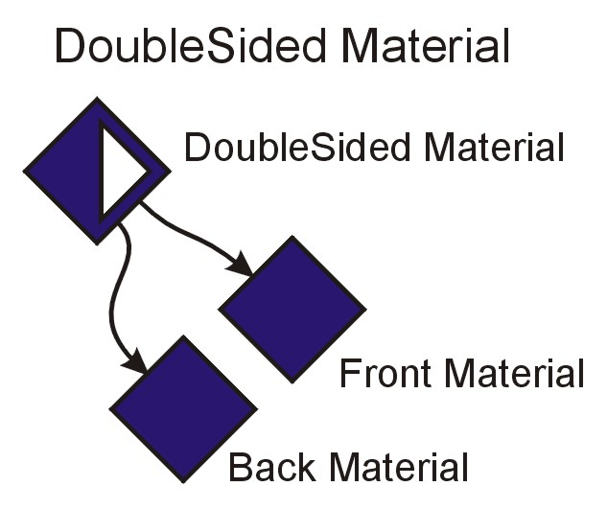
DoubleSided Material
This material references two materials; one for the front and one for the back.

SS Name
This string holds the name of the material.

IS FrontMaterialReference
This holds a 32 bit number used for accessing the front material within the material pool. If there is no material this value is -1.

IS BackMaterialReference
This holds a 32 bit number used for accessing the back material within the material pool. If there is no material this value is -1.

IS Flags
This holds the flags for the material. The definition is as follows:

Bit 0 – Front Material Enabled
Bit 1 – Back Material Enabled

FS Translucency
This floating point scalar holds the translucency amount.

Maps

A Map
This aggregate belongs as a child of the MapPool aggregate. Its name is a unique identifier within the MapPool.

SS MapType
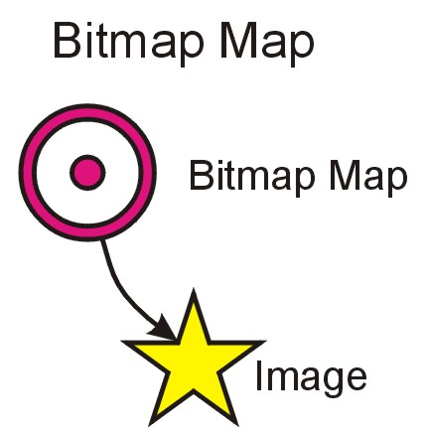
This string holds the type of map this is.

Bitmap Map
A bitmap map refers to a single bitmap image.

SS Name
This string holds the name of the map.

IS ImageReference
This holds a 32 bit integer value representing the index into the Image Pool. If there is no image this value is -1.

IS Mapping
This integer holds the mapping type. The valid values are:

0 – Explicit Map Channel
1 – Vertex Color Channel
2 – Planar from Object XYZ
3 – Planar from World XYZ
4 – Spherical Environment
5 – Cylindrical Environment
6 – Shrink Wrap Environment
7 – Screen

IS MapChannel
This integer scalar holds which explicit mapping channel to use. The value is from 1-99.

FS UOffset
This floating point scalar holds the U offset for the map.

FS VOffset
This floating point scalar holds the V offset for the map.

FS UTiling
This floating point scalar holds the U tiling for the map.

FS VTiling
This floating point scalar holds the V tiling for the map.

IS MapAxis
This integer scalar holds the axis for the UVW mapping. The values are as follows:

0 – UV
1 – VW
2 – WU

FS UAngle
This floating point scalar holds rotation about the U Axis for the map.

FS VAngle
This floating point scalar holds rotation about the V Axis for the map.

FS WAngle
This floating point scalar holds rotation about the W Axis for the map.

FS Blur
This floating point scalar holds blur factor.

FS BlurOffset
This floating point scalar holds blur offset.

FS NoiseAmount
This floating point scalar holds noise amount.

IS NoiseLevels
This integer scalar holds noise levels.

FS NoiseSize
This floating point scalar holds noise size.

FS NoisePhase
This floating point scalar holds noise phase value.

FS CroppingPlacementU
This floating point scalar holds the crop placement u value.

FS CroppingPlacementV
This floating point scalar holds the crop placement v value.

FS CroppingPlacementW
This floating point scalar holds the crop placement w value.

FS CroppingPlacementH
This floating point scalar holds the crop placement h value.

FS PlacementJitter
This floating point scalar holds the placement jitter value.

IS StartFrame
This integer scalar holds the start frame number for the animation.

FS PlaybackRate
This floating point scalar holds the playback rate of the animation.

FS OutputAmount
This floating point scalar holds the output amount value.

FS OutputRGBOffset
This floating point scalar holds the output RGB offset value.

FS OutputRGBLevel
This floating point scalar holds the output RGB level value.

FS OutputBumpAmount
This floating point scalar holds the output bump amount.

IS Flags
This integer scalar holds a series of flags. The flags are as follows:

Bit 0 – U Wrap
Bit 1 – V Wrap
Bit 2 – U Mirror
Bit 3 – V Mirror
Bit 4 – Noise Enabled
Bit 5 – Noise Animate
Bit 6 – Show Map on Back
Bits 7 – 8 Filter Type 0 - Pyramid 1 – Summed Area 2 – None
Bit 9 – Mono Channel Output 0 – RGB Intensity 1 – Alpha
Bit 10 – RGB Channel Output 0 – RGB 1 – Alpha as Gray
Bits 11 – 12 Alpha Source 0 - Image Alpha 1 – RGB Intensity 2 – None
Bit 13 – Premultiplied Alpha
Bits 14 – 15 Cropping/ Placement 0 – Disabled 1 – Cropping 2 – Placement
Bit 16 – Placement Jitter
Bits 17 – 18 Animation End Condition 0 – Loop 1 – Ping Pong 2 – Hold
Bit 19 – Output Invert
Bit 20 – Output Clamp
Bit 21 – Output Alpha from RGB Intensity
Bit 22 – Output Enable Color Map

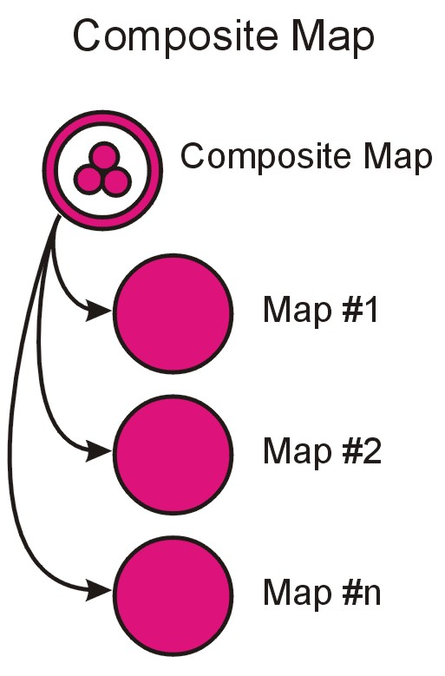
Composite Map
A composite map holds a list of other maps.

SS Name
This string holds the name of the map.

A SubMaps
This aggregate holds all the sub maps used by the composite map.

A SubMap “Index”
This aggregate holds information for a sub map. The name of this aggregate is the index within the list.

IS MapReference
This holds a 32 bit number used for accessing the correct map within the map pool.

IS Flags
This holds the flags for the sub map. The definition is as follows:

Bit 0 - Enabled

Images

A Image
This aggregate belongs as a child of the ImagePool aggregate. Its name is a unique identifier within the ImagePool.

SS FilePathName
This string scalar holds the path and name to the image file.

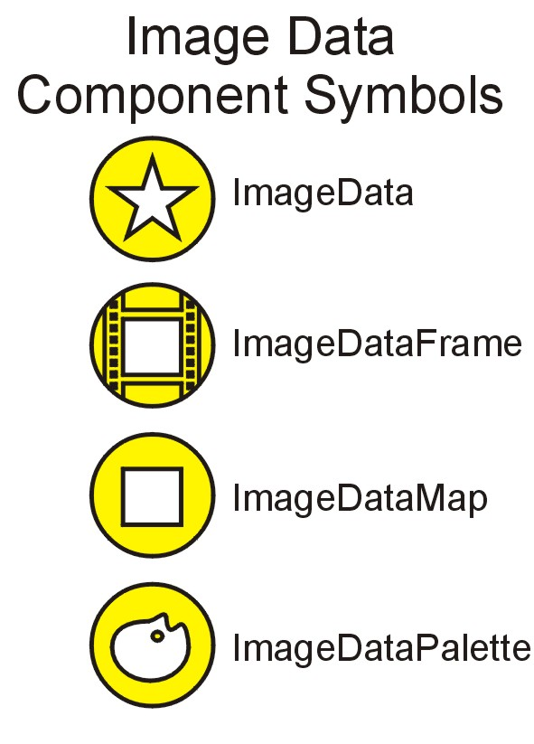
Image Data
This section covers how the actual bitmaps are stored within the Tupperware tree. The image data is not stored directly with the scene, but is stored within the image manager where image reader plugins are enlisted to read the actual bitmap files and convert them to this format. The images may then be modified in memory prior to export if needed.

A ImageData
This aggregate is the root of the tree.

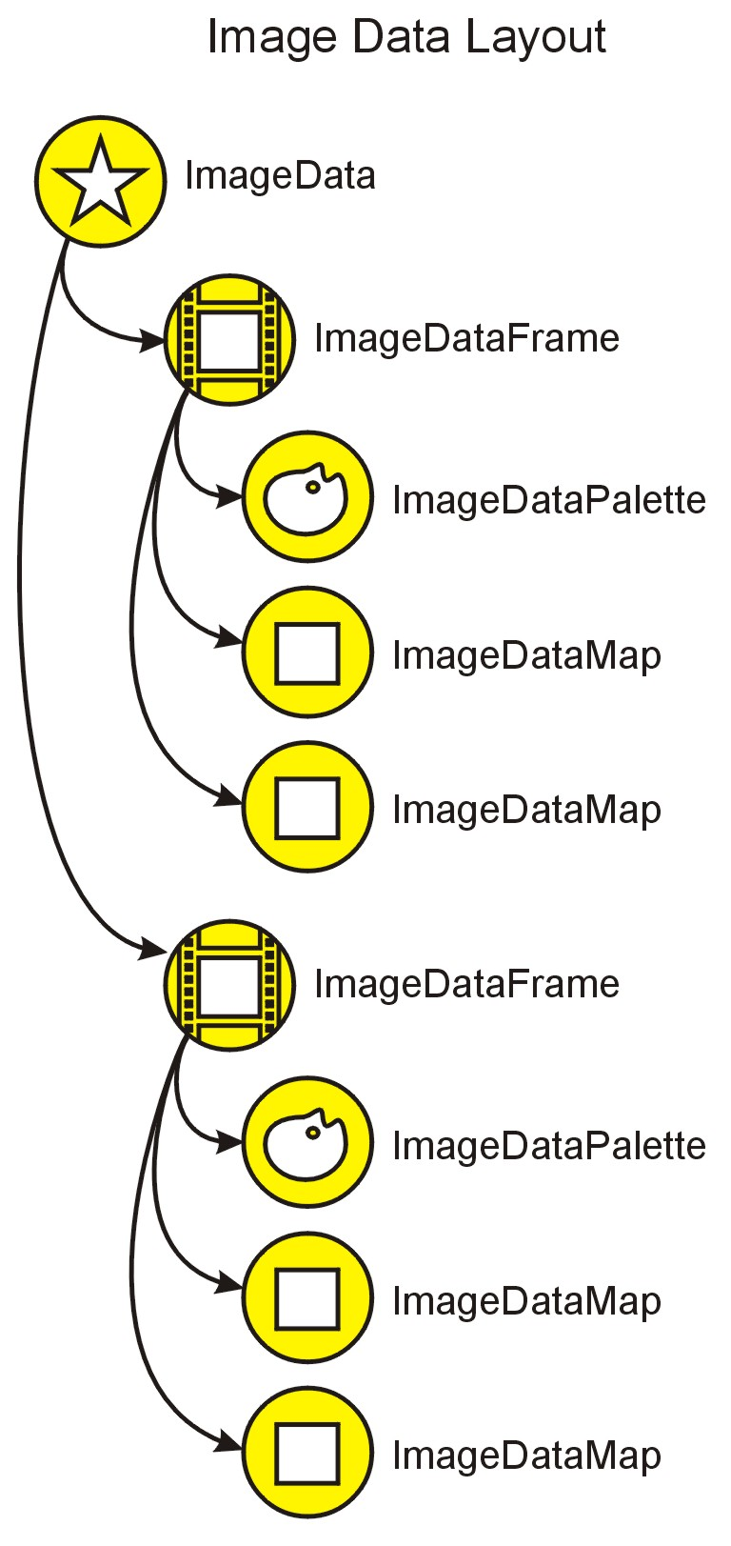
A ImageDataFrame “Index”
This aggregate holds a single frame (a bitmap will its mip maps). In order to handle texture animation, the ImageData aggregate may have more than one of these. The name of this aggregate is its position within the animation. These may not be in consecutive order.

IS FormatFlags
This integer scalar stores the flags specific to the format of the child maps. The valid flags are as follows:

Bit 0 – Has Alpha
(Add others as needed)

IS AuxilaryFlags
This integer scalar stores the auxiliary flags for the child maps. The valid flags are as follows:

(Add others as needed)

A ImageDataPalette
This aggregate contains the palette data for the frame. All mip maps within a frame share the same palette.

IS Flags
This integer scalar store the flags needed for the palette information. The valid flags are as follows:

(Add others as needed)

BS Data
This binary scalar stores the actual palette information. How this data is stored is determined by the flags.

A ImageDataMaps
This aggregate contains the maps for the frame.

A ImageDataMap “Index”
This aggregate contains the data for a single map for the frame. The name of the map is its position within the mip maps. The map with the name of “0” is considered to be the main map.

IS Width
This integer scalar holds the width of the map.

IS Height
This integer scalar holds the height of the map.

BS Data
This binary scalar holds the data for the map. How this data is stored is determined by the format flags within the frame.

